Child & Vulnerable Adults Protection Intervention Policy and Procedures

The following pages contain the London Sports Trust child protection and intervention strategy.

- Child Protection and Intervention Policy

This document states the reasons for legislation to protect children, young people and vulnerable adults and provides a framework that describes the London Sports Trust commitment, responsibilities and expectations under the child protection legislation.

- Notification Procedures for Allegations of Child Abuse

This document is an outline of the procedures to be followed by the London Sports Trust when allegations of child abuse are reported. It identifies the responsibilities of individuals, the processes that must be undertaken, aspects relating to confidentiality and the requirements of the legislation.

Child Protection & Intervention Policy

Executive Statement
The issue of child abuse is a complex problem that has an impact on all areas of society, including participation in sport and recreation activities.

Protecting children from abuse is a responsibility that we must all undertake. Through the implementation of strategies that assist in preventing child abuse from occurring, London Sports Trust has taken a pro-active role in relation to child protection and intervention. These strategies will help to foster a safe and positive environment for children and young people to participate in physical activities.

In addition, development of Child Protection and Intervention Policy and Guidelines provides the Trusts with an excellent risk management tool for developing prevention strategies and for the effective management of child abuse issues within sport.

Information contained in this document will create a framework and provide direction for staff, officials, coaches, volunteers, members and parents of children and young people involved in the London Sports Trust, and affiliated partner organisations. It will help deliver a consistent approach to child abuse prevention at all levels of the sport and recreation industry.


21/10/2025
Director Date

policy statement

The London Sports Trust is committed to ensuring that the safety, welfare and wellbeing of children are maintained at all times during their participation in activities run by the London Sports Trust and its member bodies. The Trust aims to promote a safe environment for all children and to assist all staff, officials, coaches, members and volunteers to recognise child abuse and neglect and follow the appropriate notification procedures when reporting alleged abuse.

Rationale
The focus of the policy and guidelines is the prevention of child abuse in the sporting environment.

This policy and guidelines promote the care and protection of children participating in London Sports Trust activities and provide information and direction for employees, officials, coaches, volunteers and members of the Trust.

This policy and guidelines will assist the London Sports Trust in establishing coordinated strategies for dealing with the problem of child abuse and neglect in a responsible, effective and consistent manner.

Objectives
Through the development of this policy
London Sports Trust objectives are to:

- provide information to assist staff and volunteers in dealing with all forms of child abuse

- provide comprehensive guidelines relating to risk minimisation and reporting/ notification procedures

- provide direction to all staff and volunteers regarding their legal responsibilities under child protection legislation

- promote and adopt London Sports Trust principles for child protection and intervention amongst staff, volunteers, coaches, members and parents of children participating in the Trust’s programs and activities.
- Equip all full-time staff, coaches, watersports coaches and volunteers with copies of our safeguarding policy and ensure all hold necessary certifications, training and in-house induction procedures to ensure proper safeguarding measures are maintained.

scope of POLICY
The Child Protection Intervention Policy of the London Sports Trust are applicable to all management and staff (paid, voluntary, permanent or casual) and its affiliated partners.

Implementation of Legislation
In order to implement the child protection legislation the London Sports Trust will undertake to:

- implement strategies and procedures that focus on the best interests of children and meet the requirements of child protection legislation

- promote a safe and supportive environment for all children and young people participating in activities which come under the umbrella of
the London Sports Trust .

- increase awareness and emphasise the importance of child protection issues in a sporting environment to all those involved with the activities of
the London Sports Trust. This includes administrators, coaches, officials, athletes, parents and their children.

- ensure that all staff of London Sports Trust are aware of their responsibilities arising from recent child protection legislation, in particular, the requirement under the Child Protection (Prohibited Employment) Act 1998, to inform their employers if they have been convicted of a serious sex offence.

- ensure all staff and volunteers have an enhanced DBS check when working with children and young people and that the individual has been deemed appropriate by LST staff which will be updated every 3 years.
- Ensure all Watersports staff hold the necessary qualifications issued by PaddleUK, the national authority body which included safeguarding training in order to complete a coaching qualification enabling them to lead sessions for children.

Expectations
Administrators, coaches, officials, members and volunteers often have a high level of contact with children in the sporting environment and play a major part in the successful operation of sporting activities.

Coaches and officials are often seen as role models. They have significant influence on the children they come into contact with and therefore have significant responsibilities.
The Trust expects that all administrators, officials and persons whether paid or unpaid, who participate in activities under the banner of the London Sports Trust will commit to implementing risk management strategies developed by the Trust for child protection and intervention.

Policy Review
The London Sports Trust Child Protection and Intervention Policy and Guidelines will be reviewed annually and updated in line with any legislative changes that have significant impact on the manner in which child protection and intervention issues are to be dealt with.

Signed Date 21/10/2025
Director

Notification Procedures for Allegations of Child Abuse

Rationale
The London Sports Trust acknowledges that issues regarding child abuse and the reporting of allegations of child abuse is highly sensitive, and should be dealt with in a confidential manner.

The London Sports Trust has developed these notification procedures to ensure that confidentiality is maintained throughout the process and that consistent procedures for reporting are encouraged.

The London Sports Trust will be proactive in its role to protect children and encourage an open environment that allows employees and members to be aware of their rights and responsibilities within the Trust.

Child Protection Officer
To deal appropriately with these issues and to ensure that the
confidentiality of all parties involved is maintained, one person
within the London Sports Trust will be designated as the child
protection officer.

The child protection officer is responsible for reporting any allegations of child abuse that occur at the London Sports Trust to the local branch of the Department of Social Services, and the Police Service.

- RBKC: 0207 361 3013
- H&F: 0208 753 6600 (out of hours – 0208 748 8588)
- Police: 999

If the child protection officer is not available then the most senior person within the London Sports Trust should be notified.

Child Protection Officer:

Name: UIick Tarabanov

Position: Director

Phone: 020 8735 1589

Mobile: 07540 353 020

What should be Report ed?
Some incidents may seem minor, however, they may in fact reveal more serious concerns of misconduct or a pattern of behaviour that requires further scrutiny. All people associated with the London Sports Trust should be aware of the indicators for child abuse and sexual abuse so that they may make an informed decision on what to report.

If you have reasonable grounds to suspect that a child participating in any organised activities conducted by the London Sports Trust is at risk report the matter to the child protection officer.
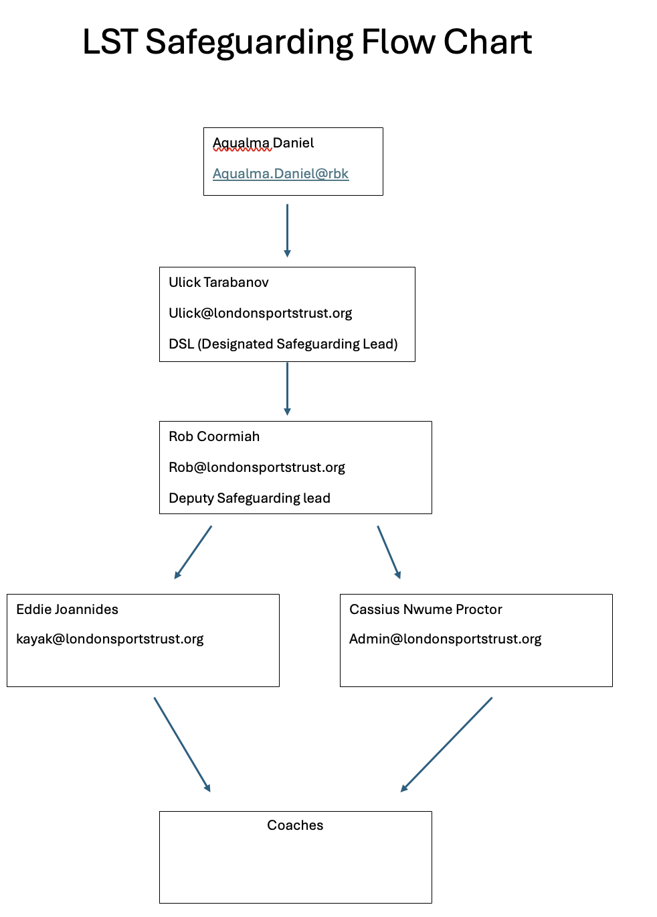

Written Notification
Verbal notification of alleged child abuse must be followed up in writing within 24 hours to the local Department of Social Services using the child protection notification form provided. (LADO - Aqualma Daniel
Aqualma.Daniel@rbkc.gov.uk)

Investigation
If an incident of child abuse occurs it is not the responsibility of persons within the London Sports Trust to take it upon themselves to determine whether the allegation is true or false. This responsibility belongs with the Department of Social Service and the Judiciary.

Depending on the nature of the allegations and the extent of the situation, Social Services will determine the manner in which the matter will be investigated. This may involve the Police Service.

Confidentiality
All matters regarding allegations of child abuse are to be treated as confidential. The person designated as the child protection officer is the contact person for any incident involving allegations of child abuse. This is essential for confidentiality. Confidentiality protects all individuals involved:

- the alleged victim

- the alleged offender, and

- the person making the notification.

Commission for Children and Young People Act 1998
Under the Commission for Children and Young People Act 1998 The London Sports Trust is required to:

- Notify the Commission for Children and Young People of the name and other identifying details of any employee against whom relevant disciplinary proceedings have been completed by London Sports Trust irrespective of the findings (except where the allegation has been proven to be vexatious, mischievous or false)

- provide details of child abuse allegations/ convictions against employees to the Commission

- notify the Commission of any applicants for child-related employment, rejected as a result of risks identified through employment screening processes
- ensure that records of all information required to be submitted to the Commission for Children and Young People are retained by
London Sports Trust

Child Protection (Prohibited Employment) Act 1998
Under the Child Protection (Prohibited Employment) Act 1998

The London Sports Trust

- will not commence employing a person in a child-related position without first requiring them to disclose whether or not they are a ‘prohibited person’

- will not commence employing, or continue to employ, in child-related employment, a person that has been identified as a ‘prohibited person’

